**P1- Stroop Effect Project**

**Background Information**

In a Stroop task, participant words, with each word displayed in a color of ink. The participant’s task is to say out loud the color of the ink in which the word is printed. The task has two conditions: a congruent words condition, and an incongruent words condition. In the congruent words condition, the words being displayed are color words whose names match the colors in which they printed. In the incongruent words condition, the words displayed are color words whose names do not match the colors in which they are printed. In each case we measure the time it takes to name the ink colors in equally-sized lists. Each participant will go through and record a time from each condition.

**1**

*What is our independent variable? What is our dependent variable?*

Independent Variable: Types of Words Condition (Congruent or Incongruent)

Dependent Variable: The time it takes to name the ink color in equally-sized lists

**2**

*What is an appropriate set of hypothesis for this task? What kind of statistical test do you expect to perform? Justify your choices.*

In mathematical notation, we consider the average time takes for congruent and incongruent types of words condition in the population and compare them.

Symbols definition:

$µ_{congruent }$: Refers to the average time takes for taking congruent test.

$μ_{incongruent}$: Refers to the average time takes for taking incongruent test.

$H_{0}:$ (Null Hypothesis)

There is not a significant difference in the time it takes to name the ink color for two types of words condition.

In other words the average time for recognizing color of these two types of word conditions are the same:

$µ_{congruent }=μ_{incongruent}$

$H_{A}:$ (Alternative Hypothesis)

There is a difference in the time it takes to name the ink color for these two types of words condition.

In other words the average time for these types of word conditions are different:

$$µ_{congruent }≠μ_{incongruent}$$

Choosing Statistical Test:

The data we have is related to a sample size of 24. So our degree of freedom is 23.We don’t have access to population parameters. This is a dependent “Two-Condition” within-subject design samples test.

Because we are looking for equality or inequality of these two averages, our point of estimate is the difference between these two averages:

Point of Estimate = $µ_{congruent }-μ_{incongruent}$

Our assumptions for this experiment are:

- Scores and difference between two scores are normally distributed.

- The sample is randomly chosen and not biased.

- Each row in dataset is related to one participant. One score is for congruent task and the other one is for incongruent task.

Base on these assumptions a two-tailed t-test with α = 0.05 is the appropriate statistical test we will choose. The reason for choosing a two-tailed test is that we do not consider a specific direction for the alternative hypothesis and we only consider the inequality of those two averages of times for congruent and incongruent tasks.

After finding the results we can tell the 95% confidence interval for the average of the difference between congruent time and incongruent time in the population.

**3**

*Report some descriptive statistics regarding this dataset. Include at least one measure of central tendency and at least one measure of variability.*

The average time spent for reading congruent words in the sample is 14.051 seconds and the average time spent for reading incongruent words in the same participants is 22.016 seconds. The median for congruent task is 14.357 seconds and 21.018 seconds for incongruent task.

The Standard deviation for data in congruent task is 3.559 and 4.797 for incongruent task.

I used the Bessel’s correction for calculating the standard deviation, because we are working on samples dataset and not on population.

Hereunder we have some descriptive statistics for this dataset:

|  |  |  |
| --- | --- | --- |
| Descriptive  Statistics | Congruent  Task | Incongruent  Task |
| Mean | 14.051 | 22.016 |
| Median | 14.357 | 21.018 |
| Standard Deviation | 3.559 | 4.797 |
| Variance | 12.669 | 23.012 |

**4**

*Provide one or two visualization that show the distribution of the sample data. Write one or two sentences noting what you observe about the plot or plots.*

First I am plotting histograms for congruent time:

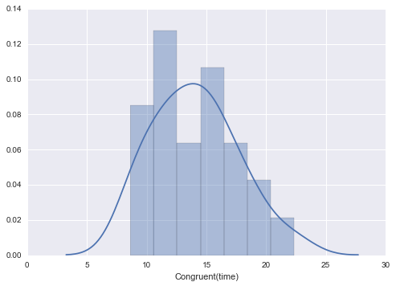

And for incongruent time:

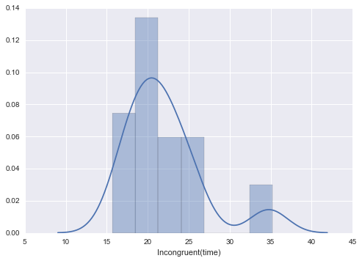

For comparing these two histograms I put both graphs in one frame:

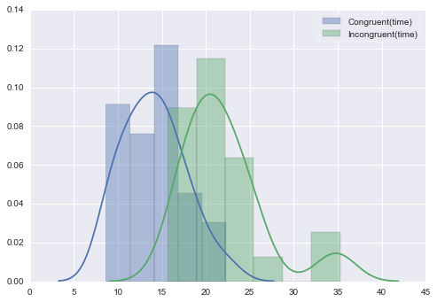

Base on this graph I observe a time shift for incongruent data compare to congruent data.

Here is the boxplot for both tasks times:

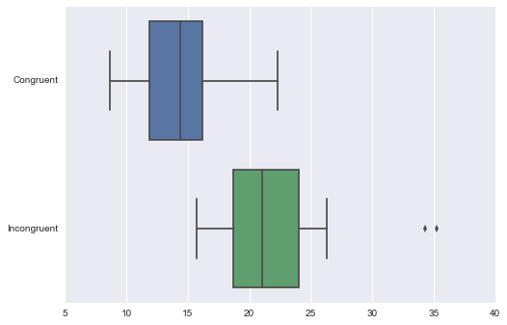

The main thing I observe from these visualizations is that there is a clear difference between these two data. Obviously the incongruent data has larger numbers and it’s seen in boxplot very clear.

**5**

*Perform the statistical test and report your results. What are your confidence level and your critical value? Do you reject the null hypothesis or fail to reject it? Come to a conclusion in terms of the experiment task. Did the results match up with your expectations?*

I perform a two sample t-test for these data. The direction of test is two-tailed. The alpha is 0.05 and degree of freedom is 23. The critical t is $± 2.069$. The t-statistic is $-8.021$.

The p-value is 0.0001;

df = 23

t(23) = $-8.021$, P = 0.0001, two-tailed

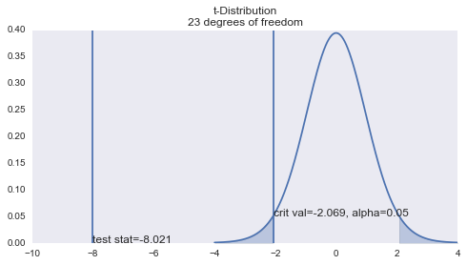

Because the t-statistic is much smaller than t-critical we can reject the null hypothesis.

It means we accept the alternative hypothesis:

Confidence Interval:

The 95% confidence interval on the mean difference is: ($-10.019$, $-5.910$)

It means if we experiment the population, the average of difference between the congruent and incongruent tasks time will be between these two numbers: $-10.019$ and $-5.910$.

Effect Size measures:

The Cohen’s d for this experiment is : $-1.64$; It means that there is a 1.64 times standard deviation distance between these two tasks time averages.

The coefficient of determination is 74%. It means that 74% of the difference between these two tasks time averages in this sample is related to the differences between two tasks.

d = $-1.64$

$$r^{2}= .74$$

Conclusion:

The average time it takes to name the congruent word list has a ‘statistical significance’ difference with the average time it takes to name the incongruent word list with the same size. It match up with my expectation; because I expect the time it takes to avoid reading the word and only distinguish the color is more than reading and considering color at the same time. Actually participants should unlearn the reading ability at the time of incongruent task. And it’s harder than using two skills at the same time in one direction for congruent words.

**6**

*What do you think is responsible for the effect observed? Can you think of an alternative or similar task that would result in a similar effect?*

**Using Two abilities**

I think one possible reason for this significant difference between average time it takes for congruent task and incongruent task is using two abilities at one or two directions.

For congruent task participants use the reading ability and distinguishing colors at the same directions. So it is easy for them to name the colors and it takes less time.

For incongruent task participants shouldn’t use the reading ability they have and it’s supposed to focus on colors only. This is a tough task. When somebody can read, it’s not easy to see a word and focus on it to distinguish its color and do not read it. So there is two source of information that may have conflict and solving this conflict takes more time than previous task.

Other possible reasons that I researched are:

**Processing Speed**

It says that brain reads faster that recognizes the colors. So participants first read the words and then they check it with color. If it’s the same (congruent) it’s easy and fast and if these are not the same it takes more time to correct first attempt.

**Selective Attention**

This theory says that brain needs more attention for solving an informational conflict than when there is no discrepancy between two sources of information it gets.

**Automaticity**

Recognizing colors is not an “automatic process” for mind. So there is a delay to respond. On the other hand reading is an “automatic process”. When we are reading, the brain does not need controlled attention and it uses e few attentional resources to reduce the amount of attention accessible for color recognition.

The possible **alternative task** could be these ones:

* 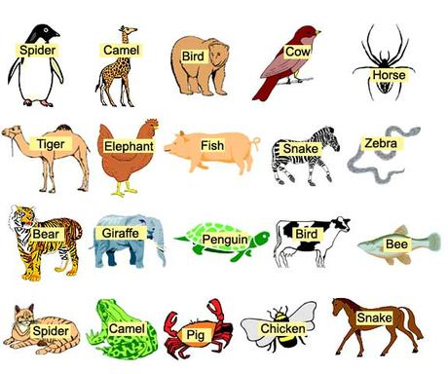On some animals pictures write the name of each animal. The congruent pictures contain animal’s pictures with correct name on them and the incongruent pictures contain wrong animal names on each animal picture. Participants should name the animal base on each picture they see and not what wrote on the picture.
* On some boxes write the name of one side (Up, Down, Left, Right); the congruent boxes contain sides with correct word on them and the incongruent boxes contain wrong direction words. Participants should name the side base on the picture they see and not what wrote on the side.

